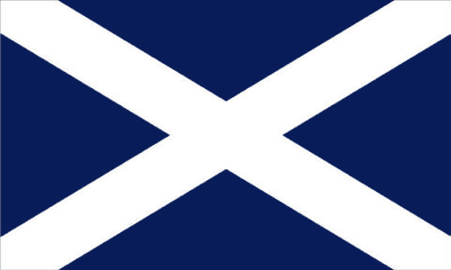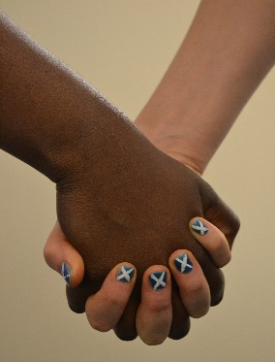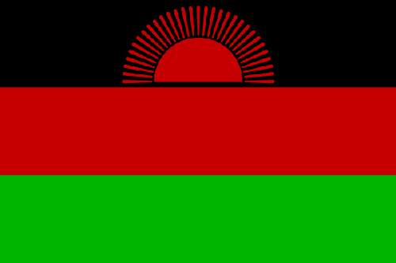
The Dalitso Project
Working Hand In Hand To Beat Poverty.

Child Sponsorship Programme Application Form

Sponsors name
Sponsors address

Contact no.
E.Mail
If you would prefer to receive update letters in paper form please
Tick here.
Please circle below your preference. Unfortunately we are not always able to meet peoples’ requests but we try our best!
Boy Girl Junior (1-11) Senior (12+)

Please fill in the details above and return to:
Becky Dunphy, 4 Princes Street, Arbroath, Angus DD11 2BL

